­­­­­

**Sales Analysis Report**

# Introduction

**Data Analysis** is a process of inspecting, cleansing, transforming, and modeling of data with the goal of discovering useful information, informing conclusions, and supporting decision-making. Data analysis has multiple facets and approaches, encompassing diverse techniques under a variety of names, while being used in different business, science, and social science domains.

Given data contains two excel sheets as Input data and Master data. Master data keeps track of the various products and categories that are bought and sold at the store. It contains the data about the buying price as well as the selling price of the product. Input data sheet keeps track of the product that are sold at a particular date and the mode through which the sale was made along with the payment mode.

Given data set keeps track of the following information:

1. Date: The date on which the product was sold
2. Payment mode: Mode of payment through which the payment was made
3. Product ID: Unique ID given to the product
4. Quantity: Quantity of the product sold on the given date
5. Sale Type: Sale mode through which the product was sold.
6. Buying price: The cost at which the product was bought
7. Category: The product to which the unique product belongs to.
8. Product: The product that was sold at given date
9. Selling Price: The price at which the product was sold
10. UOM: Unit of Measurement of the product sold

**Objective of the Dash board*:***

The team wants to see and analyze the sales trend month-wise and product-wise and make changes in their inventory. The Analytics team also wants to create analyze the database in depth to help store grow exponentially. The Analytics team wishes to answer the following objectives: -

1. Sales trend through the time of the two years
2. Total sales generated through each sales mode
3. Total sales generated by each unique category and product
4. Profit generated through sales in different modes
5. Profit generated through sales over months in different categories
6. Categories which generated more sales through time
7. Sales and Profit generated by each category
8. Sales generated through different modes over the timeline
9. Analyzing profit percent distributed through different categories
10. Sales, profit and quantity of each category product

**ETL PROCESS**

Through the process of ETL, we are going to clean the dataset and bring all the entities to their proper data format. We follow the given ETL steps before we build the report and Dashboard.

1. Load the data through ‘Get Data’ in the report page
2. Selecting the ‘Transform data’ option to transform data to power query for data cleaning.
3. Ensure no null, blanks and data type errors are in the data set
4. Removing columns like ‘Discount’ which are not useful for our analysis
5. Data formatting like giving the columns a proper name for the efficient analysis
6. Select ‘close and apply’ to load the transformed data set to power bi desktop
7. In model view, we find the input data and master data are in a ‘one-to-many relationship’ with single cross filter direction
8. Format the data properties of each data entity like changing:

Quantity – Summarized by – Average

Selling price – Format – Decimal

Buying price – summarized by - Average

1. Now, create a ‘Date Table’ to keep track of the time intelligence functions and measures and to create hierarchy of ‘year-quarter-month-date’
2. Join the ‘Date table’ with input data with ‘date’ as common column with a ‘one-to-many relationship’
3. Create ‘year’, ‘Quarter’, ‘month’, ‘year’, and ‘month num’ coulmn in date table
4. Create ‘Date hierarchy’ for time intelligence reports and filtering
5. Create ‘Category hierarchy’ with product and category columns
6. Create ‘profit’ column
7. Create ‘profit %’ column
8. Make sure all the tables are connected and with single cross filter direction.

**List of New columns and measures created for analysis:**

1. Cost price

Cost price = sumx(InputData, InputData[QUANTITY]*related(MasterData[BUYING PRIZE]))

1. Profit:

profit = [Total sales]-[Cost price]

1. Profit % :

profit % = ([profit] * 100)/[Cost price]

1. Total Sales:

Total sales = sumx(InputData, InputData[QUANTITY]*related(MasterData[SELLING PRICE]))

1. Total Sales Average Per Category:

Total Sales average per CATEGORY =

AVERAGEX(

    KEEPFILTERS(VALUES('MasterData'[CATEGORY])),

    CALCULATE([Total Sales]))

1. **Total Sales YTD:**

Total Sales YTD =

TOTALYTD([Total Sales], 'Date'[Date])

1. **Date Column:**

Date = generate(CALENDARAUTO(), var yy = year([Date]) var mm = month([Date]) return row("Year", yy, "Month num",mm, "Month",format([Date], "MMM")))

1. **Quarter:**

Quarter = "Q" & CEILING('Date'[Month num]/3, 1)

**Sales Analysis Visuals**

1. Sales over time through years, quarters and months

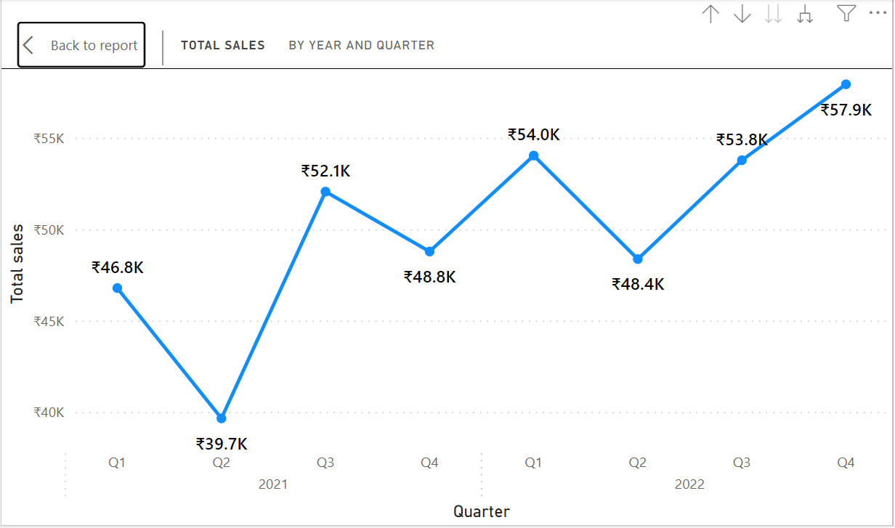

Property settings: Adding ‘Date Hierarchy’ on x-axis and ‘Total Sales’ measure on y-axis fields in the visualization pane. Adding data labels and changing font size for effective visualization.

1. Sales over time through different modes

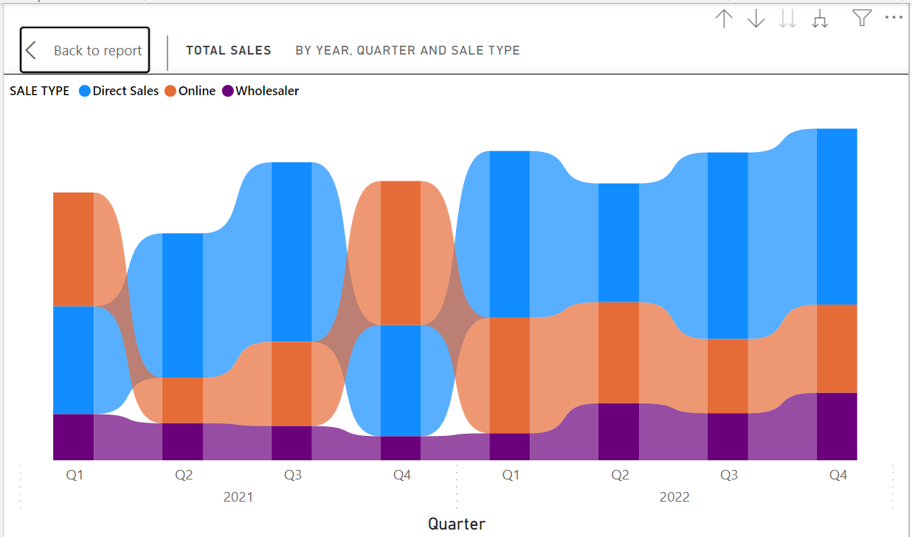

Property settings: Adding ‘Date Hierarchy’ on x-axis, Total sales on y-axis, and selecting ‘Sale type’ as legend to find the rankings of different sales mode generated sales over the time.

1. Total sales by category:

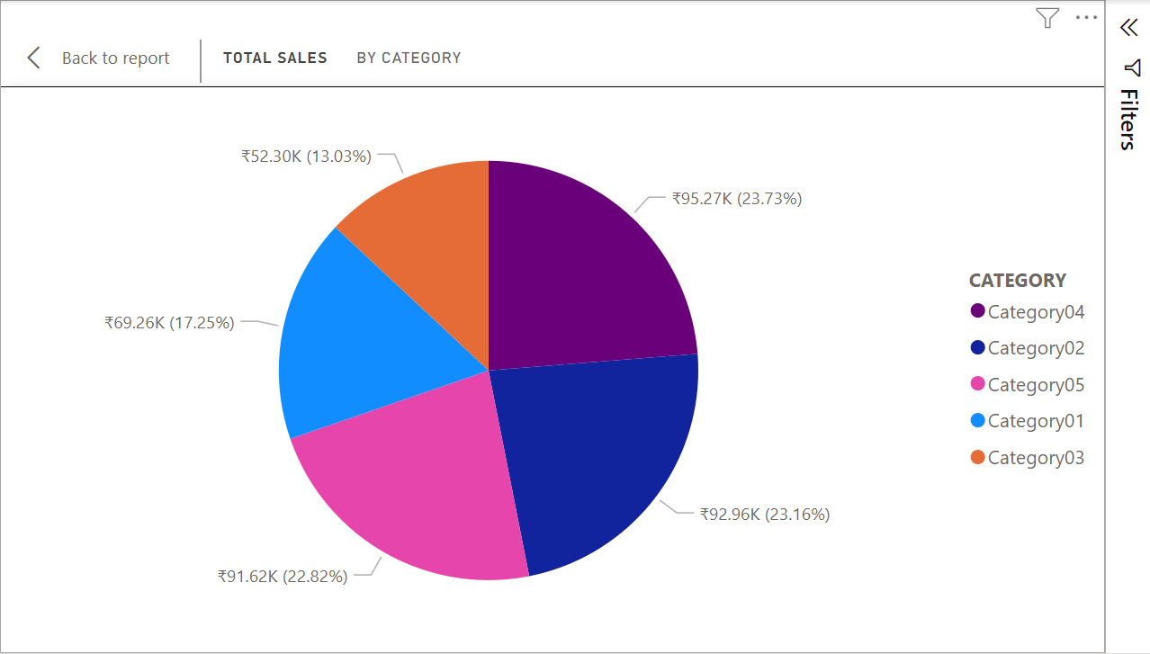

Property settings: Adding Total sales to ‘values’ field and category to ‘Legend’ field to visualize the distribution of sales over various categories.

1. Total sales by sales type

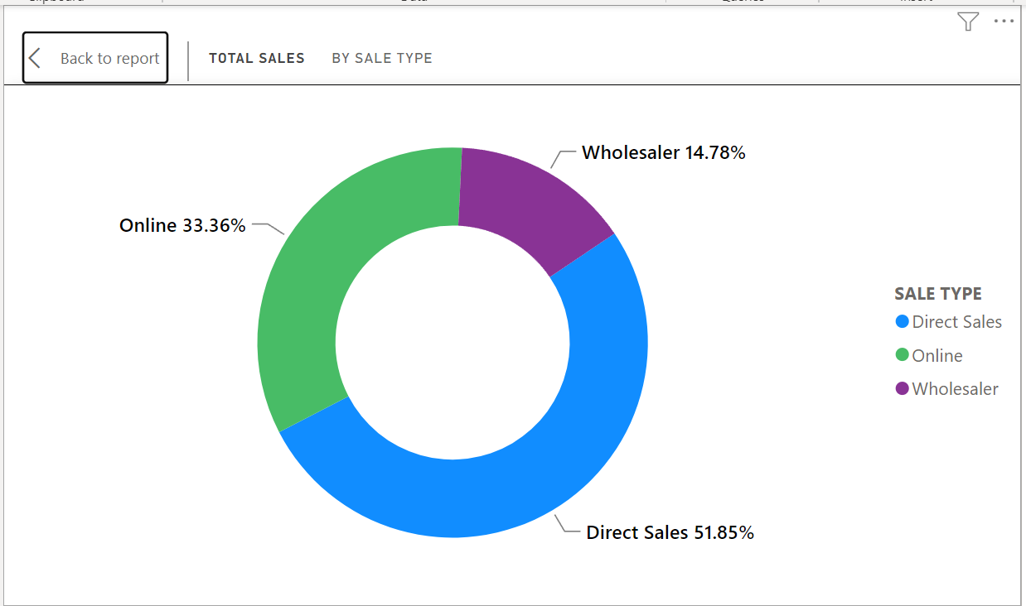

Property settings: Adding Total sales to ‘values’ field and sale type to ‘Legend’ field to visualize the distribution of sales over various categories.

1. Sales and Profit by category

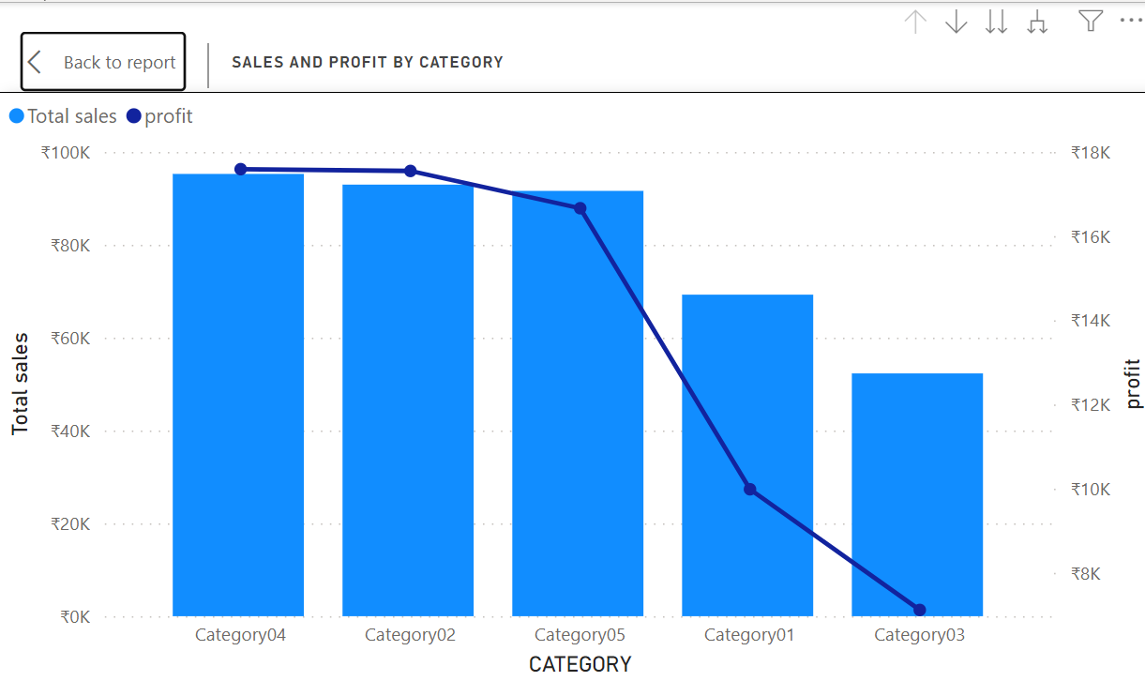

Property settings: Adding ‘category’ to x-axis field and ‘Total sales’ to y-axis field. On top of that, using ‘profit’ on secondary y-axis for analyzing the profits trend over categories along with the sales generated.

1. Sales by sales type and selling price

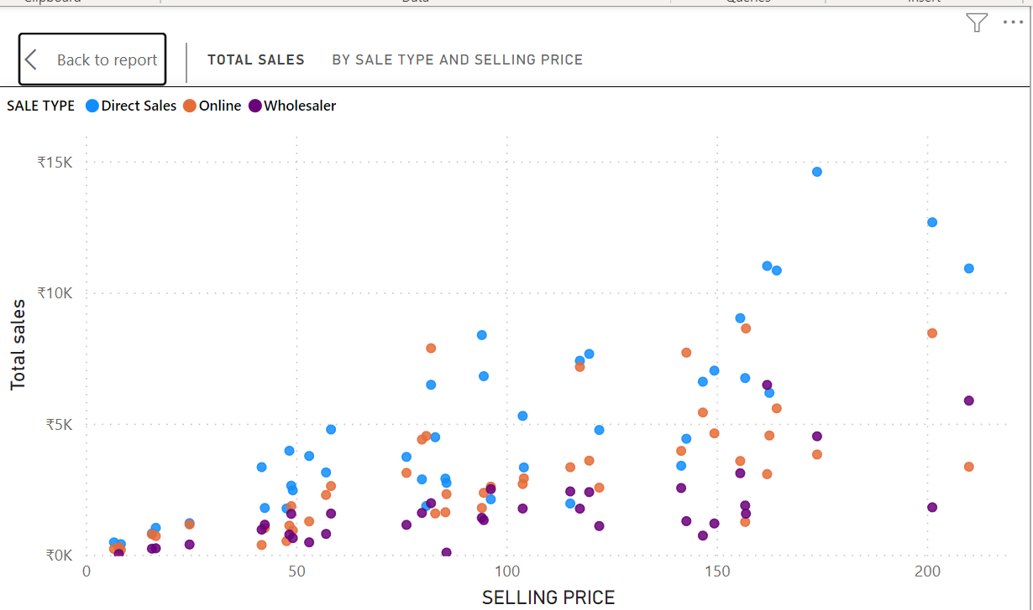

Property settings: Adding ‘selling price’ to x-axis and ‘Total sales’ to y-axis. On top of that, using ‘Sale type’ as legend will help us the role of different sales mode performance in generating sales.

1. Sales quantity by category

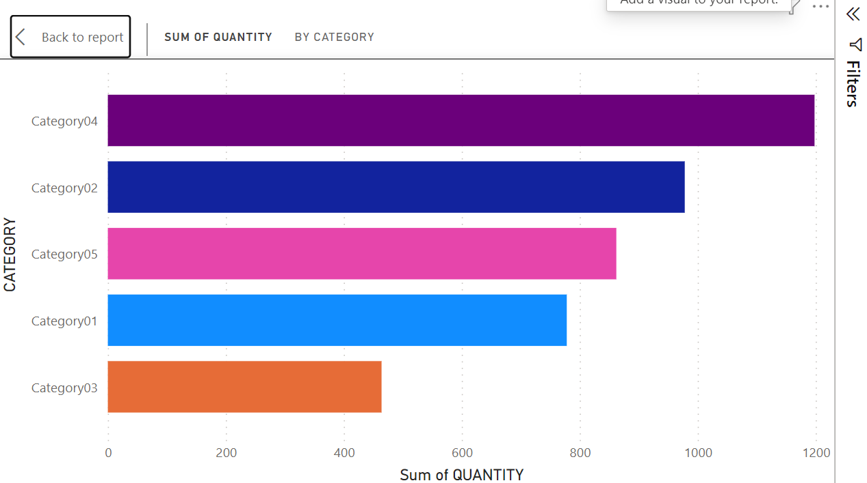

Property settings: Adding ‘Quantity’ on x-axis summarized with sum operation and ‘category’ on y-axis. This helps in visualizing the customers preference based on the quantity purchased by customers.

1. Payment mode by category

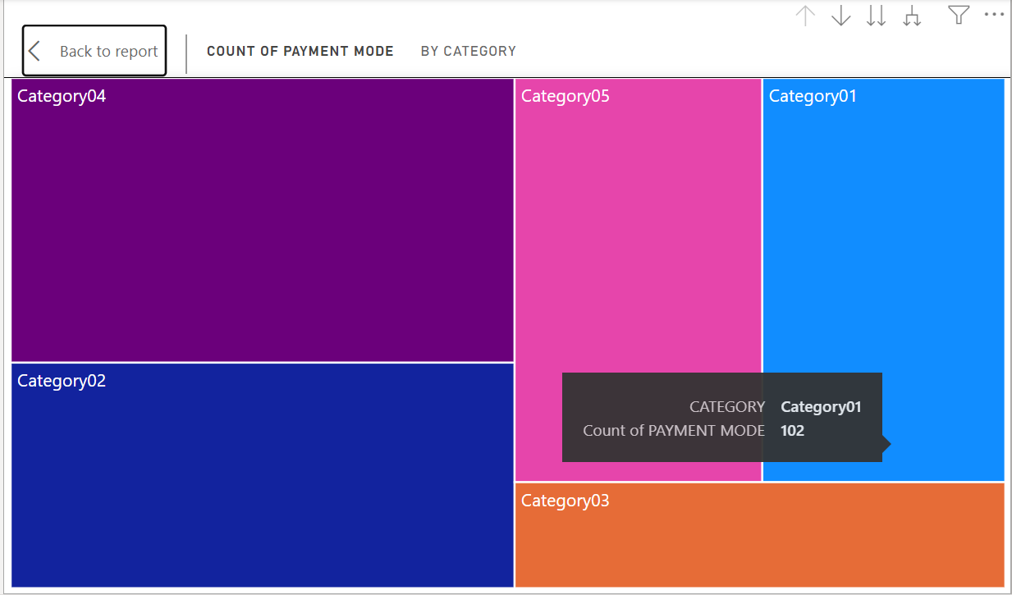

Property Settings: Adding ‘category hierarchy’ on category pane and ‘count of customers using specific payment mode’ on value field. Since we added the category hierarchy we can also visualize customers preference payment mode in each category.

1. Profit by category and selling price

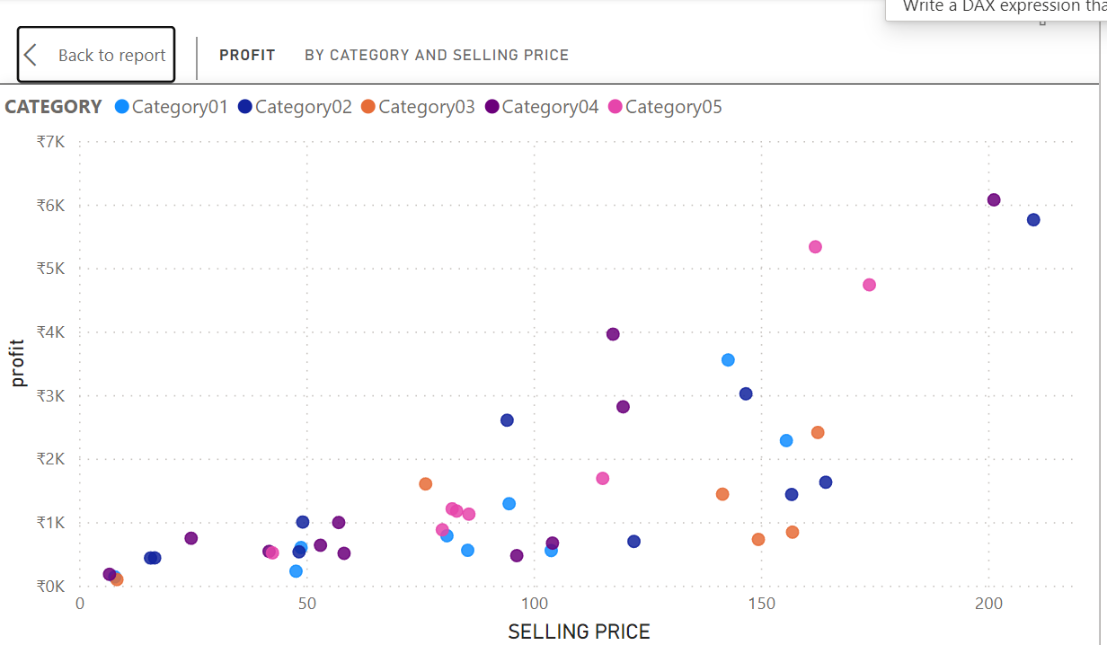

Property settings: Adding ‘selling price’ to x-axis and ‘Total sales’ to y-axis. On top of that, using ‘Sale type’ as legend will help us the role of different sales mode performance in generating sales.

1. Profit % by sale type

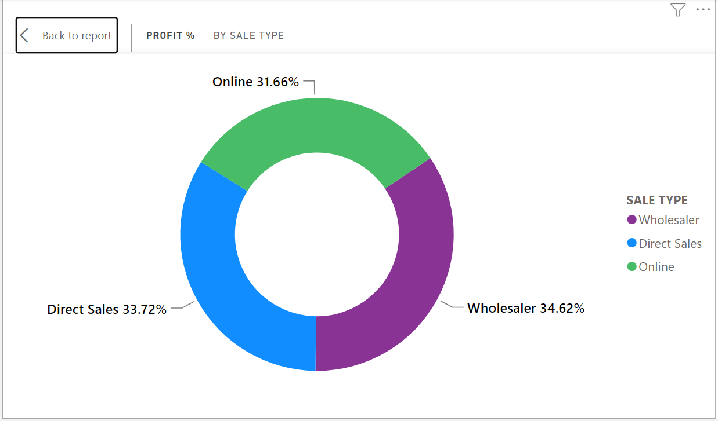

Property Settings: Adding ‘profit’ to value field and ‘sale type’ to legend field. This visualization shows the profit share over different sales types.

1. Sales pareto analysis

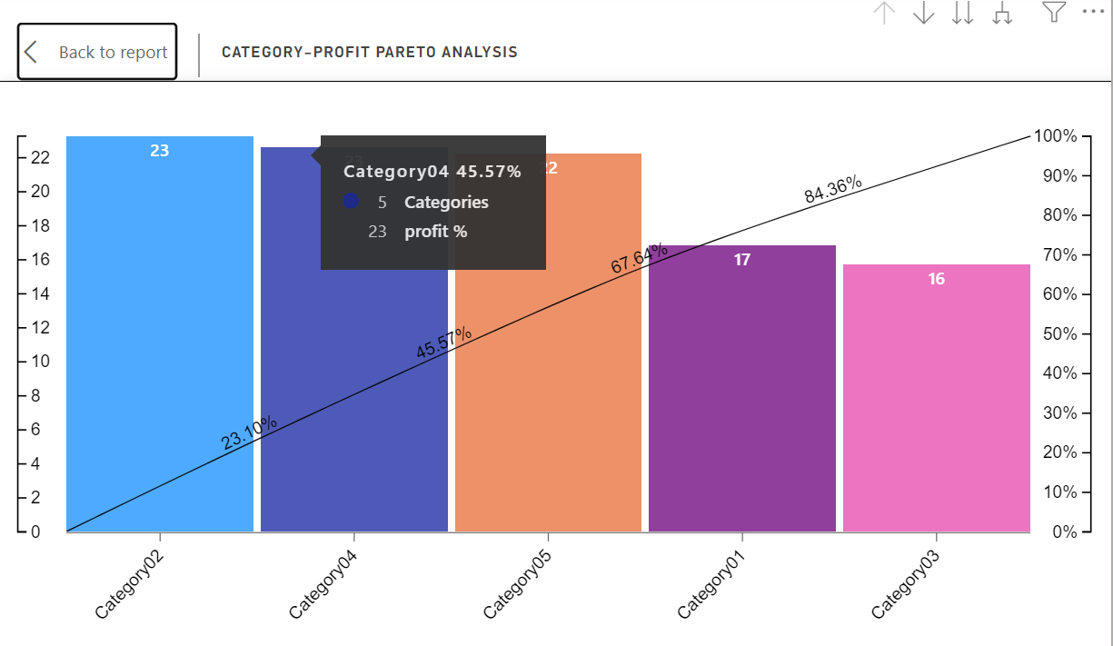

Profit Settings: Creating a pareto chart to find the main category contributing to profits generated over sales over time. We can see top 3 categories are contributing to more than 50% of profits.

1. Sales through sales mode over time

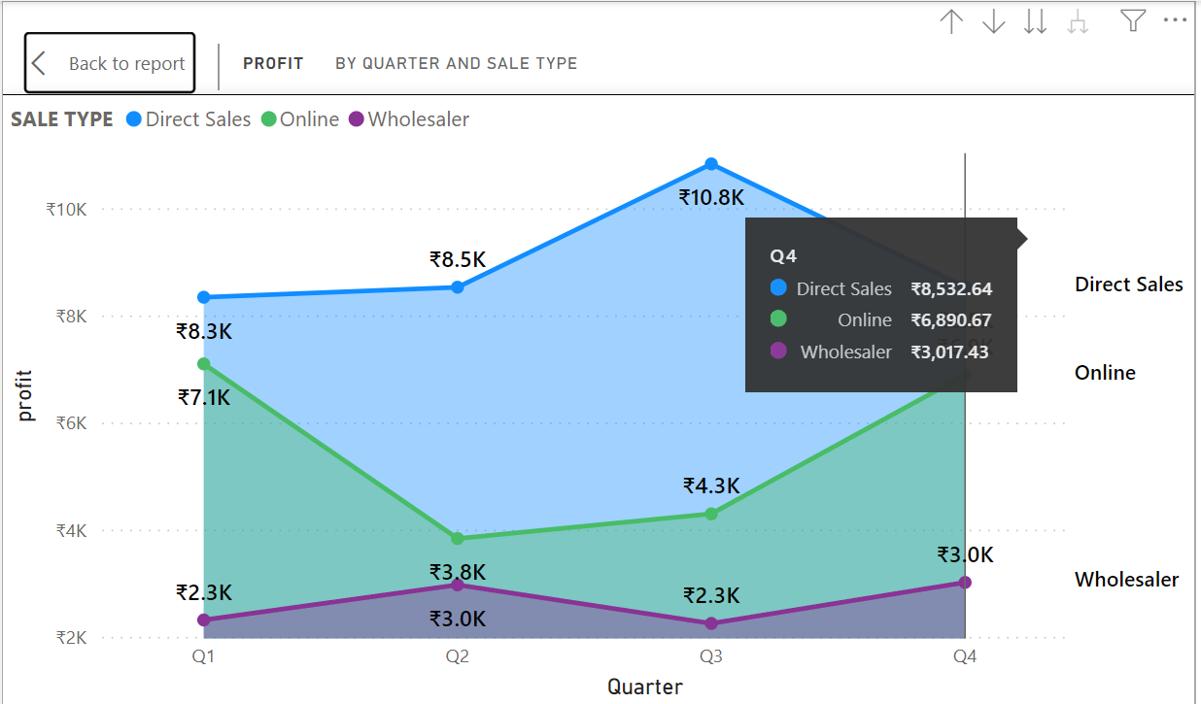

Property settings: Adding ‘Date Hierarchy’ on x-axis field and ‘profit’ on y-axis field. On top of that add ‘Sale type’ on legend field of area chart.

1. Detailed Matrix table

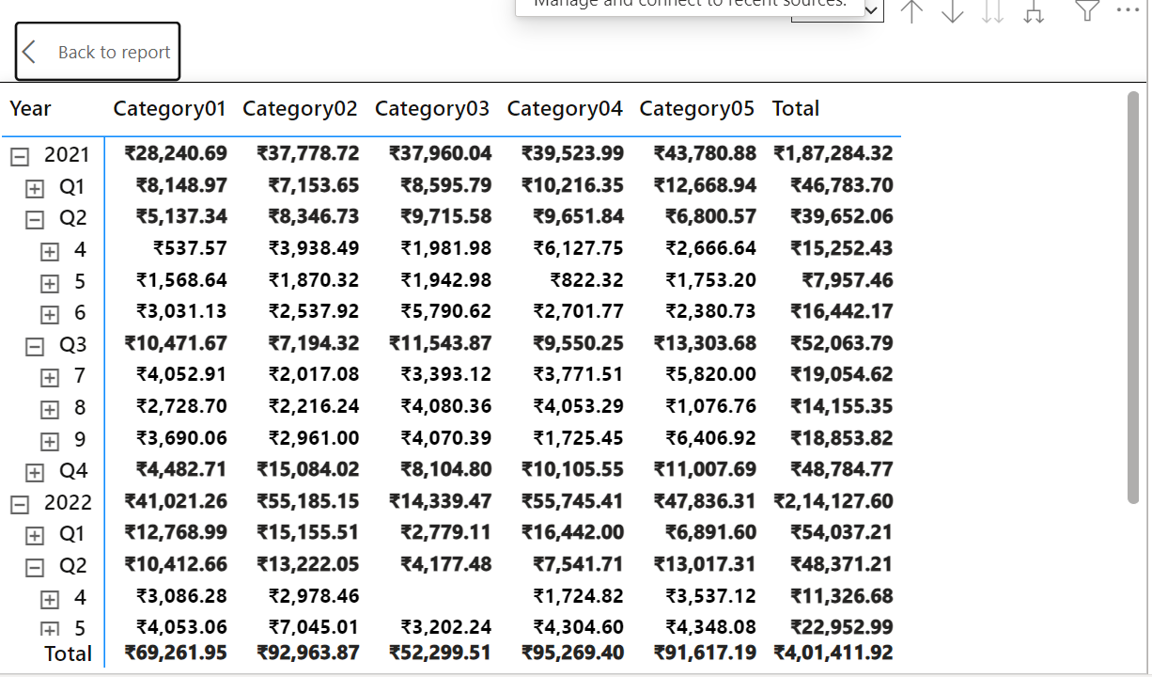

Property settings: Adding ‘Date hierarchy’ on row field, ‘Total sales’ on values field and ‘category hierarchy’ on columns field. This matrix visualization helps in detailed and easy understanding of the Sales particulars.

1. AI based Q&A

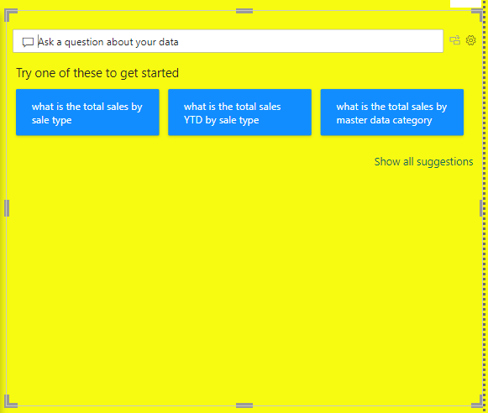

Property settings: This is an AI based Q&A visual. This visual helps in generating visuals and answers based on the questions asked in layman terms.